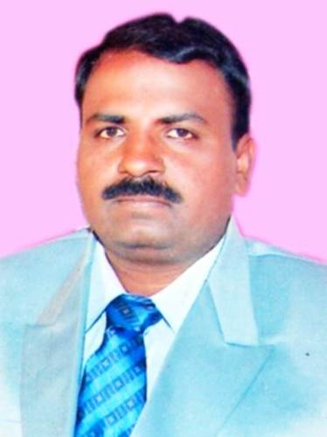
PERSONEL PROFILE

J PRABHAKAR M.Sc., M.Phil
Lecturer in Zoology
S.K.P Government Degree College,
Guntakal, Anantapur District, Andhra Pradesh.
Mobile: 9440443724
Email: jp.atkl123@gmail.com
---------------------------------------------------------------------------------------------- Academic Qualifications and Other details:
Subject : Zoology
Highest Educational : M.Sc., M.Phil.
Employee ID ( for regular staff only ) :
Date of Birth :01-061973
Social Category : BC-B
Religion :Indian-Hindu
Gender :Male
- Date of Joining service as : 16-11-2000
- Lecturer in Degree College : 01-03-2005
- In S.K.P. College, Guntakal :19-09-2015
- Awards and Achievements :

3. Educational Details:
S. No | Class | Name of the Institution and Place | From | To | % of marks Division | Board/  University
1 | SSC | ZPHS Devanakonda | 1987 | 1988 | III | Board Of Secondary Education, AP.
2 | Inter | The Adoni Arts&Science College, Adoni. | 1988 | 1990 | II | Board Of Intermediate Education, AP, HYD.
3 | UG | The Adoni Adoni Arts&Science College,Adoni. | 1990 | 1993 | I | Sri Krishna Devaraya University, Anantapur.
4 | PG | Kuvempu University, BR Project, Shimoga. | 1994 | 1996 | II | Kuvempu University, Karnataka.
5 | M.Phil | VMU Salem | 2007 | 2008 | II | VMU, Tamilanadu

4.Previous Professional (Teaching) Experience :
S.No | Institution | From | To | Designation | No.of Years
1 | GJC Kosigi,Kurnool.Dist | 16-11-2000 | 04-03-2005 | Junior LEecturer | 05years
2 | GJC Kodumur,Kurnool Dist | 05-01-2005 | 28-02-2005 | Junior Lecturer | 02 months
3 | GDC Pathikonda,Kurnool Dist | 01-03-2005 | 31-03-2013 | Lecturer | 08years
4 | GDC(M) Kurnool | 08-07-2013 | 28-01-2013 | Lecturer | 01years
5 | GDC(M)Nandikotkur | 28-02-2014 | 31-03-2014 | Lecturer | 01month
6 | SJGDC(A)Kurnool | 21-07-2014 | 02-09-2015 | Lecturer | 01year
7 | SKPGDC, Guntakal | 19-09-2015 | 08-10-2020 | Lecturer | 05years
8 | GDC(M) Kurnool | 14-10-2020 | 03-09-2021 | Lecturer | 01year
9 | PVKN GDC(A) Chittoor | 25-09-2021 | 05-07-2022 | Lecturer | 01year
10 | GDC(M) Kurnool | 14-07-2022 | 15-09-2022 | Lecturer | 02months
11 | SKP GDC Guntakal | 16-09-2022 | Till to Date | Lecturer

a.API Score for

a)2015-16 :
b)2016-17 :
c) 2017-18 :
d) 2018-19 :

b.Papers and Sections handled ( 2019-20)

S.No | Course | Medium | Title of the Paper
1 | I B.Sc. | TM&EM | Animal Diversity- Invertebrates
2 | IB.Sc. | TM&EM | Animal Diversity- Vertebrates
3 | IIB.Sc. | TM&EM | Cell Biology,Genetics&Evolution
4 | IIIB.Sc. | TM&EM | Immunology
5 | IIB.Com | EM&TM | Environmental Studies

5.National / International seminars or Work Shops/Trainings attended :

S.No | National/ International | Institution/place | Date | Title of the paper Presented
1 | NEP National seminar | SV University Tirupati | 22.3.22to23.3.22
2 | Poultry Forming TOT | GDC(M) Anantapur | 02-11-22to 6.11.22
3

6 . Books Authored :

7. BOS / Member of Academic Bodies :

8. Paper Setting for other academic bodies :

9 . Paper/Journal Publications :

S.No | Title of the Paper | Name of the Journal | Year/Edition | ISSN/ISBN No

10 . Extension Lectures / Invited Lectures Delivered :

S.No | Institution | Topic | Date

11. Any other Curricular/Co curricular/Extracurricular Activities involved

